AgriGuard: Screenshots and Explanation
This document provides a visual walkthrough of the AgriGuard system, demonstrating the complete user journey from edge-device image capture to federated performance tracking.

Figure 1: Initial Dashboard & Interface
Explanation: This is the clean, offline-first Streamlit Operating System (OS) designed for rural farmers. The interface prioritizes ease of use, allowing farmers to quickly select an image source (Take a Picture or Upload from Gallery). The left sidebar clearly separates the "Field Diagnosis" tool from the developer-facing "Global Network Stats," ensuring a streamlined user experience.
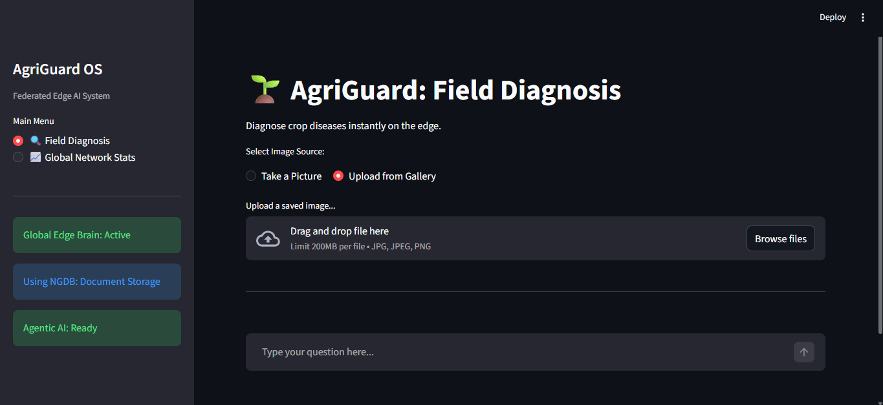

Figure 2: Image Upload & Validation
Explanation: Once a farmer uploads a high-resolution leaf image, the system queues it for edge analysis. Before the deep learning model activates, the image passes through our OpenCV vision filter (The "Bouncer"). This step mathematically verifies that the image actually contains plant matter by analyzing the HSV color space, preventing non-plant objects (like faces or dirt) from wasting the mobile device's compute power.
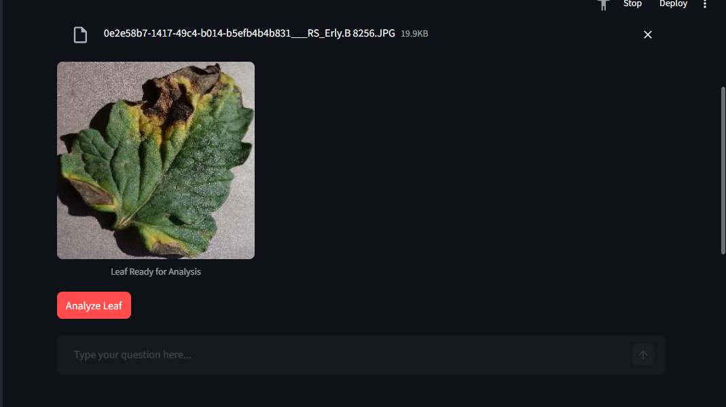

Figure 3: Disease Diagnosis & Offline Remedies
Explanation: This screen showcases the core inference and retrieval engine.
- The MobileNetV2 Edge AI successfully identifies the specific disease (e.g., Tomato - Target Spot).
- The OpenCV Pipeline calculates the exact severity percentage (29.03%) by comparing diseased pixels to healthy green pixels.
- The system instantly queries the local, offline Document Database (remedies.xml) to retrieve standard organic and chemical protocols. Because this uses an document database structure, the retrieval happens instantly on the device with zero internet latency.
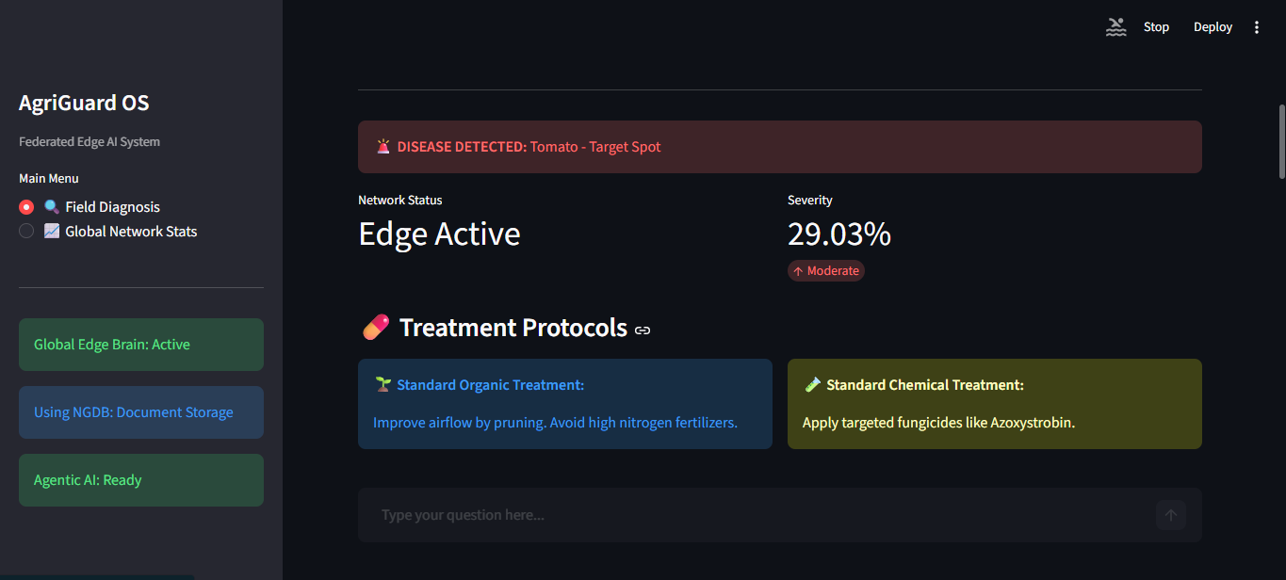

Figure 4: Agentic AI Prescription
Explanation: For highly personalized advice, the system features an Agentic AI Chatbot powered by the Gemini Large Language Model. To prevent AI hallucinations (inventing fake chemical names), the system uses a Retrieval-Augmented Generation (RAG) pipeline. It forces the LLM to read the scientific facts from our local XML document database first, acting as a professional digital agronomist that expands on the standard treatments safely and contextually.
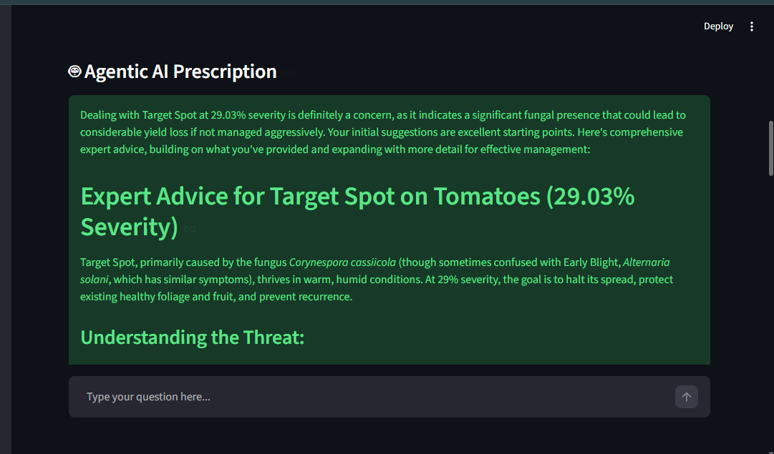

Figure 5: Federated Learning Performance
Explanation: This visualization proves the success of the decentralized architecture. The chart maps the global model's convergence across 20 Federated Learning rounds. It demonstrates how the flwr framework successfully aggregated "math updates" from 3 active edge nodes processing over 21,000 images, reaching a final projected accuracy of 92.5%—all without a single raw image ever leaving the smartphone
